I have been happily engrossed in ‘all things Laudato Si’’ for more than two years. Having been so concerned about nature for so long, I welcome committing to work on her behalf.
What strengthened my commitment is what is happening to the Florida coral reef system that my great-uncle John Pennekamp (with a FL state park in his name) strove to protect in 1963. This reef system is now on the ICUN red list – all within 58 years of my life. 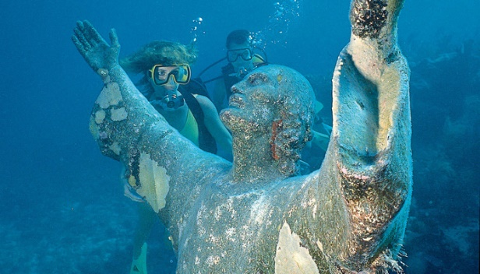
Gratefully I completed the Laudato Si’ animator training. I encourage everyone to enroll. As a result I continue to learn so much from people throughout the world. This is a global movement. Starting a Laudato Si’ Circle to pray for, reflect on and act for creation has encouraged me. We have members from Ohio, North Carolina, New Hampshire, Wisconsin and California – and you are welcome also. We meet by Zoom on the second Wednesday of every month from 7-8pm ET. Email Monica at: laudatosicircle@gmail.com to get on our invite list.
We distributed an Eco Lent 2022 calendar – below – which even high school teachers used. For Laudato Si’ week, plans are to provide prayer/faith stones with a Beatitudes inspired by Laudato Si’ handout. I look forward to our continuing plans. There is so much we can do. Let’s all have Laudato DO’ moments!
Monica from Cincinnati, Ohio and Raleigh, North Carolina
.
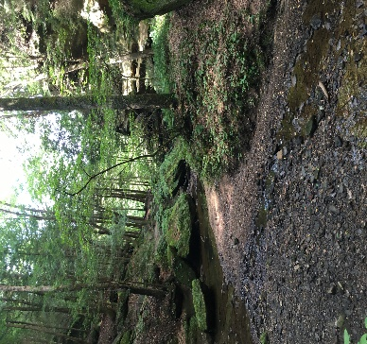  Trees at Lake Wheeler Park, Apex, N.C. | Lent 2022  Picture: Hocking Hills, OH March 2nd – April 16th  Lent 2022  March 2nd – April 16th  Lent 2022  March 2nd – April 16th  Lent 2022  March 2nd – April 16th  Lent 2022  March 2nd – April 16th
The Earth Is | The Lord’s And Everything In It
Sun. | Mon. | Tue. | Wed. | Thu. | Fri. | Sat.
 |  |  | 2 Ash Wednesday | 33 | 4 | 5
  Laudatosimovement.org  Email: for mtg info  laudatosicircle@gmail.com  St. A Laudato Si’ Circle monthly Wednesday meetings |  |   Building A Better Future Together  Laudatosiactionplatform.org | In today’s Ps 95:8, we are told, “not to harden our hearts.”  May these Lenten practices draw us closer to God, our neighbor and creation. | All recent Popes have spoken on our eco responsibilities.  Reflect and pray on St. Pope John Paul II’s “Peace with God the Creator, Peace with All of Creation.”  bit.ly/JP2- on-ecology | Calculate your carbon footprint at: 3.epa.gov/carbon-footprint-calculator  Take note of your most carbon producing activities. | Write a note to a child in your life who inspires you to sustain God’s creation for future generations.
6 1st Sunday of Lent | 7 | 8 | 9 | 10 | 11 | 12
In Luke 4:2 we hear after forty days Jesus was hungry-and undeniably thirsty.  Nearly 1 billon people have no access to clean water. | “We praise you Lord, for Sister Water, so useful, humble and pure.” St. Francis of Assisi.  Read or sing the, ‘Canticle of the Sun’. | Try a “water fast”, turn off water while brushing teeth, flush your toilet half as often.  In the world, many people have access only to the amount of water each day that Americans use in one toilet flush. | Visit: waterfootprint.org. To learn more about your water footprint. Say a prayer of gratitude every time you sip water today.   | Estimated consumer cost for manufacturing plastic bottles; the amount of water required; one liter "inside" plus two liters for production. | Estimated pollution; over 17 million barrels of oil are needed to produce 31.2 billion liter-bottles used in the U.S.; these bottles created over 2.5 million tons of CO2 in 2006. | Use your own water bottle. An estimated 1 million plastic bottles are bought each minute. Commit to using your own glass or reusable bottle.  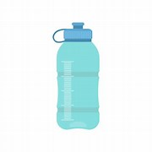
13 2nd Sunday of Lent | 14 | 15 | 16 | 17 St. Patrick’s Day | 18 | 19
“To your descendants I have given this land.” Genesis 15:18.  Talk to your church leaders: could your church be greener? | 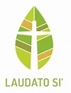Read 2015 encyclical by Pope Francis: Laudato Si’ | "You are not making a gift of what is yours to the poor man, but you are giving him back what is his... The earth belongs to everyone, not to the rich." St Ambrose.  Help climate refugees | PFAS chemicals don’t break down, they build up and move into water systems; for information go to:  Cdc.gov/biomonitoring  /PFAS_FactSheet | Use an object of nature-i.e. a shamrock, or something similar, to explain the Trinity to someone. | Remove one light bulb and live without it for the next 30 or more days.   | Give up two degrees: for every degree the thermostat is below 70 in the winter or above 76 in the summer there’s a 3- 5% savings in energy use and cost.
20 3rd Sunday of Lent | 21 | 22 | 23 | 24 | 25 The Annunciation | 26
“I shall cultivate the ground around it and fertilize it; may it bear fruit in the future.” Luke 13:8  How can we lovingly and joyfully answer the call to be Christ’s disciple? | 40% of all food in the U.S. is wasted, while 1 in 8 people in the U.S. suffers from hunger. Problem solve reducing food waste. Get ideas at: epa.gov/sustainable-management-food | 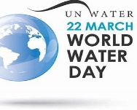  Worldwaterday.org  Learn – Share - Act | Decide to go organic in your garden this spring. Grow your lawn & garden without toxic chemicals. Leave grass clippings on the lawn and cut the grass higher. | Learn to compost. Find out what a huge difference it makes and why.  Watch a short video: https://www.youtube.com/  watch?v=bqDQD8cvO5Y&t=8s | Tread lightly upon the earth: walk or bike instead of driving.  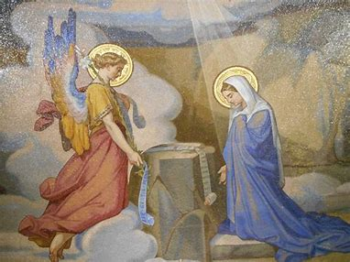 |   Supported by 19 Catholic organizations, check the website:  Catholicclimate  covenant.org
27 4th Sunday of Lent | 28 | 29 | 30 | 31 | 1 | 2
“he squandered his inheritance on a life of dissipation.” Luke 15:13  How can we be responsible steward’s of creation? | Watch ‘The Story of Stuff” an on line video  And  take the Plastic Free Pledge at: www.storyofstuff.org | Avoid buying fruits and vegetables in plastic packaging. Bring your own boxes or reusable bags.  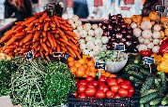 | Look around your kitchen. See what plastics you can replace when they wear out with wooden or metal items. | Give an experience rather than a plastic gift to a child, family member or friend.  Take them on an outing instead.  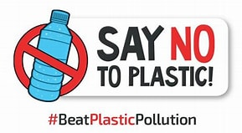 | Avoid products with micro beads and polyethylene, used as an exfoliant in soaps, toothpaste and body wash. | Lose the clingfilm and Ziplock bags. Use a glass or stainless steel container with lid for food storage, leaving room at the top.
3 5th Sunday of Lent | 49 | 5 | 6 | 7 | 8 | 9
“Restore our fortunes, O Lord” Ps 126:4  To show love for our Creator, we respect and protect all of creation. | Reducing meat consumption by 15%, saves greenhouse gas emissions equal to taking 240 million cars off the road yearly. Plan Meatless Monday meals at: meatlessmonday.com | Avoid PFAS’s found in clothing, furniture, adhesives, food packaging, heat-resistant non-stick cooking surfaces, and the insulation of electrical wire. | Try not to add any items to the landfill today. Use real cups, cloth napkins, reusable bags for groceries, and reusable water bottles.  What else can you think of? | Refuse plastic lids and straws. It is estimated by 2050 that there will be more plastic in the oceans than fish by weight!  Watch this documentary on how to save our oceans: www.seaspiracy.org | Shift to cleaner energy at home by buying 100% renewable power on your electricity bill.  Find out more at: www.green-e.org/certified-resources# | One adult receives around 41 lbs. of junk mail yearly. Requiring 53 million trees and 56 billion gallons of water to produce. Call 1, 2 or more companies to unsubscribe.
10 Palm Sunday | 119 | 12 | 13 | 14 Holy Thursday | 15 Good Friday | 15 Holy Saturday
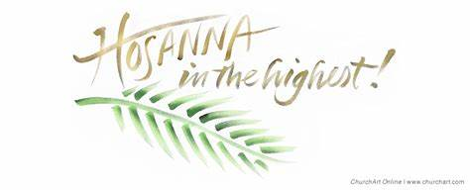  A donkey, the Mt. of Olives and palm branches, “The Master has need of it.”  Luke 19:34 | As we follow Christ’s journey this Holy Week, may we lament of the world around us. Climate injustice, poverty, hunger, and human suffering seem to abound. May we pray to God, as Jesus taught us, trusting that God hears us. | Wangari Maathai's 2004 Nobel Peace Prize affirmed that protecting and planting trees contribute to peace.  What is the connection? | “Behold, behold, the Wood of the Cross.”  The tree that became Jesus' cross had a history that dated back millennia. | Reflect and pray on Pope Benedict XVI’s message for the World Day of Peace, “If You Want to Cultivate Peace, Protect Creation.”  bit.ly/pope-benedictprotect-creation | Healing the planet, empowering it’s people, planting 7 million trees; check out: laudatotree.org  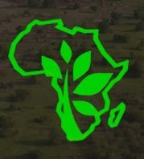 | “God looked at everything He had made, and found it very good.” Genesis 1:31.  God loves diversity. Make contact with a person different from you.  Adopt one of these Lenten practices for the year ahead.

