St. Stephen parish reflection Feb 2022

St. Stephen, Deacon and Martyr Parish in Tinley Park is in Vicariate V of the Archdiocese of Chicago. We have been involved with Creation Care since February, 2018 . We joined with several parishes in our cluster (St. Elizabeth Seton, and St. Julie Billiart) to form a Creation Care Committee. Eventually St. Francis Assisi and Our Lady of the Woods would join also. Our purpose is to promote the message of Pope Francis in his Encyclical Laudato Si’, to address the “cry of the Earth and the cry of the poor” (LS 49).

The parish holds regular food drives on the 3rd weekend of the month, sponsored by the St. Vincent de Paul Society to benefit the Tinley Park Food Pantry and St. Lawrence O’Toole Food Pantry. We hold a Fair Trade event at Christmas featuring crafts from the Holy Land. We have a strong tradition of respecting life from birth to natural death.

Other ministries that are active in our parish include St. Stephen Carry Out Meals, the Prayer Shawl Ministry, Bereavement Ministry, Hands on Ministry, This Man is You (with St. George), Hope Employment Ministry (with St. Elizabeth Seton), Young Adult Ministry, Altar Serving, Cantors, Lectors, Ushers/Greeters, Ladies Social Club, Men’s Club, Seniors Young at Heart, Counseling and Support Groups, RCIA (Rite of Christian Initiation for Adults with St. Elizabeth and St.George) and Religious Education for grade schoolers and the Polish School. We are also part of the Cardinal Joseph Bernardin Regional Catholic School.

We have a number of opportunities to enrich our Faith Life, including daily Adoration of the blessed Sacrament, First Friday devotions to the Sacred Heart, the Rosary Group, and Scripture Study.

The parish has a vibrant Polish Community which strongly supports the parish, especially enriching the spiritual life with various devotions.

The Creation Care efforts are to educate and advocate for the preservation of our natural environment. To that end we have provided the showing of two movies at St. Elizabeth Seton, “The Human Element”, and “Merchants of Doubt”:

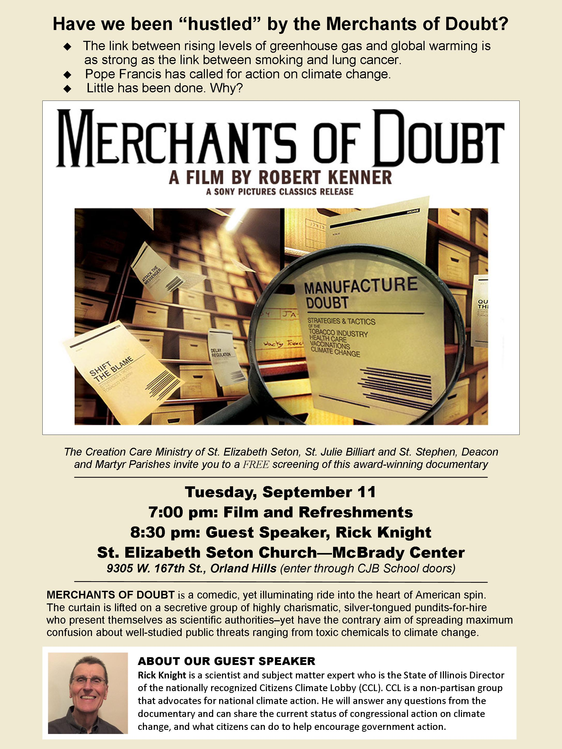

We have held pledge drives at St. Stephen to sign up parishioners to encourage support for the aims of Pope Francis’ Encyclical. Members from the committee have established relationships with national Catholic organizations and have networked with other Creation Care Teams to share best practices. They have also lobbied Illinois and U.S. Congressional Representatives to promote legislative solutions to climate change and have developed a bulletin insert called Creation Care Corner which provides sustainability tips for parishioners.

We have presented a display to the parish about the harm plastics cause to 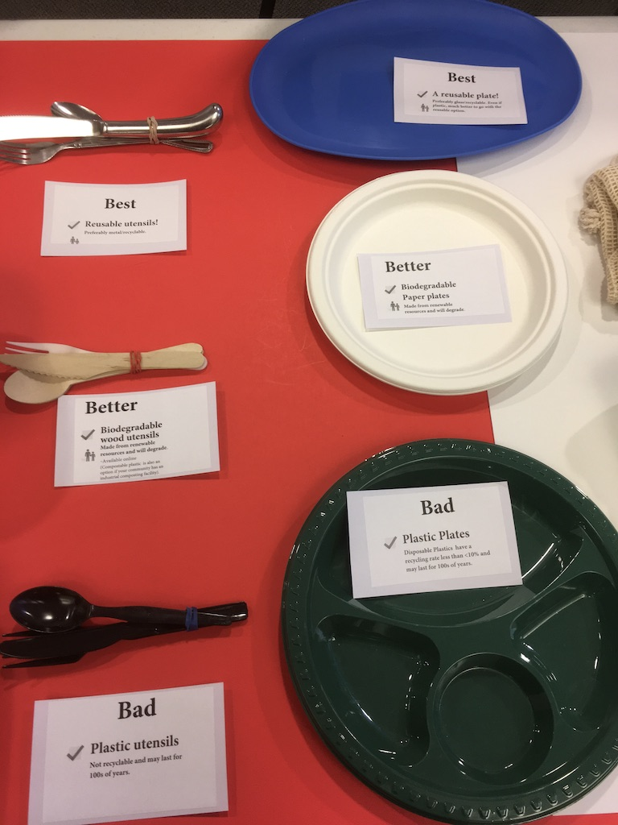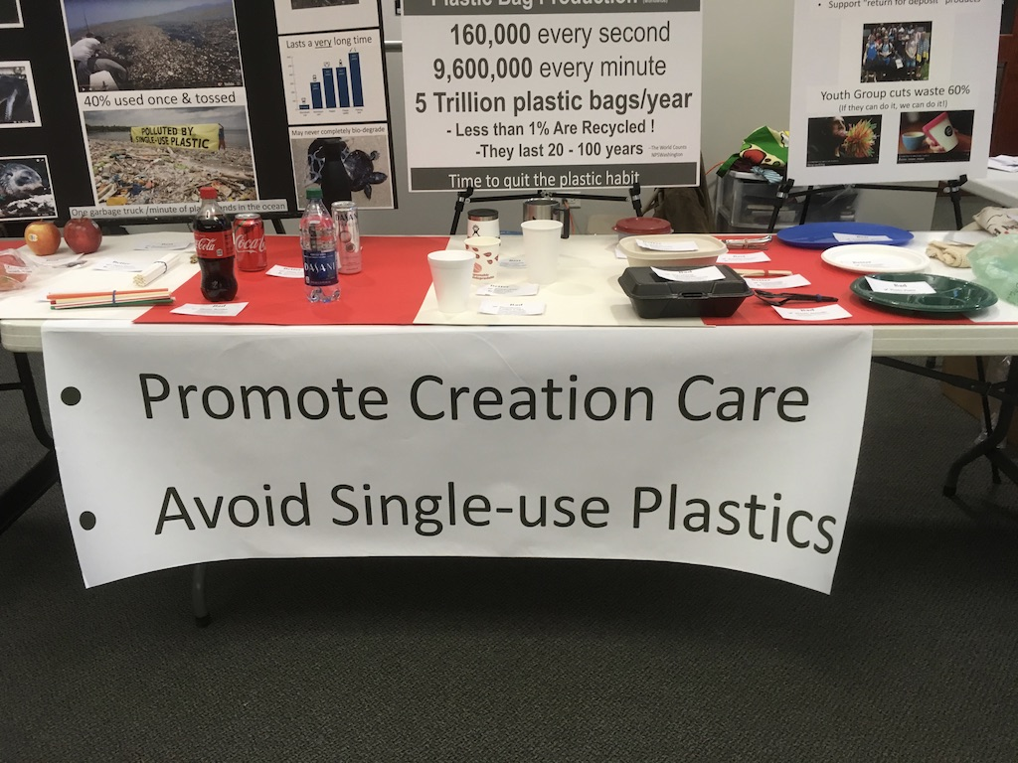the environment:

St. Stephen has a dedicated garden to St. Francis, acknowledging his care towards animals with a plaque and statue on church grounds. The plaque is dated 2005.

The garden includes a decorative rock, which says, "Let Us Care for Our Common Home" by Pope Francis. This must have been added sometime after 2013.

This depicts St. Stephen’s commitment to spreading the good word of Creation Care.

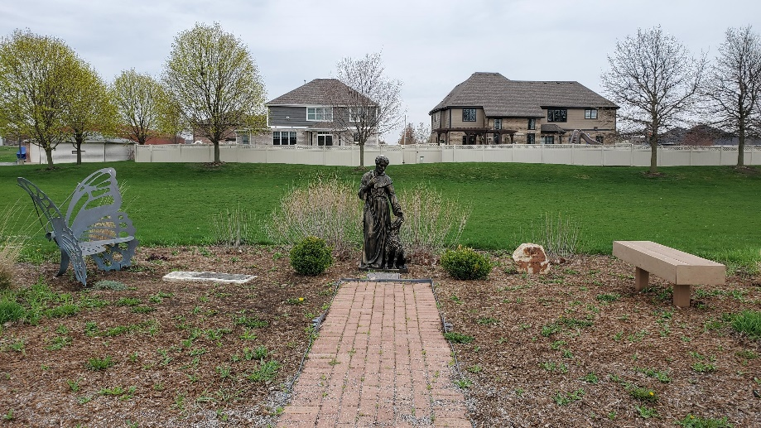

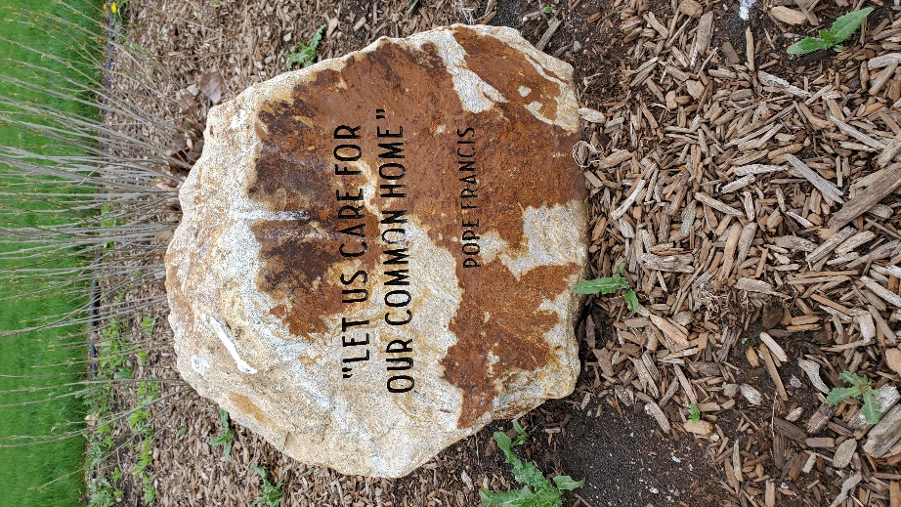

The People of God in St. Stephen Parish are empowered by the Spirit to build the Christian Community through worship, education, and service. St. Stephen Deacon and Martyr Church brings the love of our Creator and Redeemer to “hear the cry of the Earth and the cry of the poor” through the message of Laudato Si’.